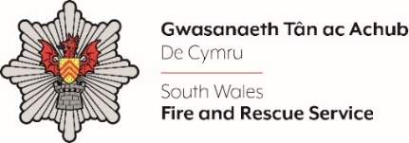
Shortlisting evidence Template – Control Operator 2024

Dear Candidate,

Please complete the form below in FULL adhering to the shortlisting criteria outlined in the personal specification. Then save in a Word document format and upload to the ‘supporting evidence’ section of the online application.

Please note that for shortlisting purposes we will be removing ‘Name’ and ‘National Insurance number’ and each candidate will be provided with a candidate number for anonymised shortlisting.

For any queries please contact personnel@southwales-fire.gov.uk

Full Name:
National Insurance Number:
Anonymised Candidate Number (to be completed by FRS HR team)
Shortlisting Criteria 1:
Functional experience of Windows based applications.
Shortlisting Criteria 2:
Must have experience of working in a busy environment, providing advice and assistance to members of the public, e.g. Call centre or customer care experience.
Shortlisting Criteria 3:
Maintain confidentiality in relation to data protection.
Shortlisting Criteria 4:
Ability to maintain confident and resilient attitude in highly challenged situations.
Shortlisting Criteria 5:
Positive about change and adapting to different ways of working, Asks for and acts on feedback, learning from experience and developing own professional skills and knowledge.
Shortlisting Criteria 6:
Ability to work effectively with others both within the Fire & Rescue Service and in the community.
Shortlisting Criteria 7:
Will remain calm and professional under pressure.
Shortlisting Criteria 8:
Ability to adopt a conscientious and proactive approach to work to achieve and maintain excellent standards whilst also displaying personal integrity.

Closing date - 12:00pm midday on Monday 22nd July 2024

